
REPUBLIC OF CAMEROON
PEACE-WORK-FATHERLAND
UNIVERSITY OF BUEA
BUEA, SOUTH-WEST REGION
P.O BOX 63.

RÉPUBLIQUE DU CAMEROUN
PAIX-TRAVAIL-PATRIE
UNIVERSITÉ DE BUEA
BUEA, RÉGION DU SUD-OUEST
B.P. 63.

FACULTY OF ENGINEERING TECHNOLOGY

COMPLETE REPORT ON THE IMPLEMENTATION OF A QoE MOBILE APPLICATION FOR CAMEROON (NETLINK)

Course Title: Internet Programming and Mobile App Development

Course code: CEF440

Course Instructor: Dr Nkemeni Valery

Date: July, 2026

Name | Matricule
THELMA MARLEY NDAYINU | FE23A171
EKWEMBWE NKWELLE JUNIOR | FE23A044
MBUH ASSURANCE MULUH PILA | FE23A091
NYUH DELBERT KIMBI | FE23A129
YASIRI TEMWA GASTON | FE23A175

Table of Contents
Abstract 4
Preface 5
1. Introduction 6
1.1 Background 6
1.2 Problem Statement 6
1.3 Proposed Solution 6
1.4 Objectives 7
1.5 Mobile Application Development Context 7
1.6 Scope and Limitations 7
1.7 Significance 8
1.8 Report Structure 8
CHAPTER 2: REQUIREMENT GATHERING 9
2.1 Introduction 9
2.2 Stakeholder Identification 9
2.2.1 Smartphone Users 9
2.2.2 Network Service Providers (MTN, Orange, Camtel) 10
2.3 Requirement Gathering Techniques 10
2.4 Data Gathering and Cleaning 10
2.5 Key Insights from the Data 13
2.6 User Reluctance Assessment 14
2.7 Summary of Findings 14
CHAPTER 3: REQUIREMENT ANALYSIS 15
3.1 Introduction to Requirement Analysis 15
3.2 Review and Analysis of Gathered Requirements 15
3.2.1 Completeness of Requirements 15
3.2.2 Clarity of Requirements 15
3.2.3 Technical Feasibility: Platform Decision 15
3.2.4 Feature-Level Feasibility Summary 16
3.2.5 Dependency Relationships 17
3.3 Identification of Inconsistencies and Missing Information 17
Inconsistencies Found 17
Missing Information 17
3.4 Requirement Prioritization 18
3.5 Requirement Classification 18
Functional Requirements 18
Non-Functional Requirements 19
3.6 Software Requirement Specification (SRS) Overview 19
System Overview 19
Data Architecture: Offline-First with Cloud Sync 19
Privacy Alignment 20
Scalability Consideration 20
Inputs, Outputs, and System Users 20
3.7 Requirement Validation with Stakeholders 21
3.8 Summary of Requirement Analysis 21
CHAPTER 4: SYSTEM MODELLING AND DESIGN 23
1.The Context Diagram: 23
2. Dataflow Diagram 23
3. Use Case Diagram 24
4. Sequence Diagrams 25
5. Class Diagram 26
6. Deployment Diagram 27
CHAPTER 4: APP IDENTITY AND VISUAL DESIGN 29
4.1 App Identity 29
4.2 Visual Design Principles 29
4.3 Colour Tokens and Typography 30
4.4 Screen-by-Screen Design 30
CHAPTER 5: FRONTEND IMPLEMENTATION 33
5.1 Composable Structure 33
5.2 State Management (MVVM) 33
5.3 Navigation and Routing 33
5.4 Domain-to-UI Mapping 33
CHAPTER 6: DATABASE DESIGN AND BACKEND IMPLEMENTATION 35
6.1 Data Elements 35
6.2 Conceptual Design 35
6.3 Entity-Relationship Diagram 36
6.4 Database Implementation 36
6.5 Backend Implementation 36
6.6 Connecting Database to Backend 37
6.6.1 Local Database: 37
37
6.6.2 Cloud Database (Supabase with posgresSQL) 38
CHAPTER 7: GOALS ACHIEVED 39
7.1 Summary of Achievements 39
CHAPTER 8: SWOT ANALYSIS AND FUTURE ENHANCEMENTS 40
8.1 SWOT Analysis 40
8.1.1Strengths 40
8.1.2 Weaknesses 41
8.1.3 Opportunities 42
8.1.4 Threats 42
8.2 Future Implementations 43
8.3 Additional Future Implementations 44
APPENDIX (Table of Figures) 45
REFERENCES 46

Abstract

Mobile network operators in Cameroon have no reliable, automated mechanism to collect Quality of Experience (QoE) data directly from subscribers in real time. Existing monitoring infrastructure measures network performance from the operator side but remains blind to what subscribers actually feel during daily usage. This gap between Quality of Service as measured by operators and Quality of Experience as felt by subscribers is the central problem this project addresses.
This project presents netLink, a native Android mobile application built with Kotlin and Jetpack Compose that collects both objective network performance indicators and subjective user experience ratings from mobile subscribers in Cameroon. The system follows an Offline-First architecture, persisting all data locally using Room Database before synchronizing anonymized records to a Supabase cloud backend. Privacy is enforced through a one-way SHA-256 hash of a device-generated UUID, ensuring no personally identifiable information ever leaves the subscriber's device.
The project was developed across six structured phases: requirement gathering through a 121-response survey and MTN staff interview, requirement analysis producing a complete IEEE 830 SRS, system modelling producing six formal UML diagrams, UI design establishing a complete visual system across three actor types, and database design implementing a two-tier storage architecture with a WorkManager-driven sync pipeline and operator-facing aggregated SQL views. The result is a functional, privacy-conscious, battery-efficient application that delivers actionable anonymized QoE insights to network operators without exposing any individual subscriber data.

Preface

This report documents the design and development of netLink, the group project deliverable for CEF440-Internet Programming and Mobile Programming at the Faculty of Engineering and Technology, University of Buea, during the 2025–2026 academic year.
The project was undertaken by Group 23, supervised by Dr. Valery Nkemeni.
The work spans seven structured tasks covering the full software development lifecycle, The problem domain was motivated by the direct experience of group members as mobile subscribers in Buea, shaped by the real constraints of Cameroonian mobile users: affordable devices with aggressive battery optimization, intermittent connectivity, predominantly non-technical users, and deep daily dependence on mobile data.
The authors acknowledge the 121 survey respondents whose participation provided the empirical foundation for the system's design, and the MTN Technology Staff member who validated the operator-side data gap through a structured interview.

1. Introduction

1.1 Background
In Cameroon, mobile data has become an essential utility for millions of people in daily commerce, education, healthcare and communication. Despite sustained infrastructure investment by MTN Cameroon, CAMTEL Cameroon and Orange Cameroon, subscribers continue to experience persistent quality challenges: dropped calls, slow data, frequent disconnections and high latency during peak hours.
Operators deploy sophisticated QoS monitoring infrastructure that measures technical network performance from the infrastructure side. However, a critical gap exists between what this monitoring measures and what subscribers actually experience. QoS answers whether the network is functioning as designed. It does not answer whether the network feels fast, reliable and usable in the context of real daily activities. That measure; the subscriber's subjective perception, is Quality of Experience (QoE), and it cannot be derived from QoS data alone.
The consequence is that operators make network planning decisions based on an incomplete picture, discovering problems reactively through customer care complaints rather than proactively through real-time subscriber data.

1.2 Problem Statement
Mobile network operators in Cameroon lack a reliable tool to collect real-time, combined subjective and objective QoE data directly from subscribers, making it impossible to proactively identify and address network quality problems from the subscriber's perspective. Existing feedback mechanisms are manual, asynchronous and unstructured. No independent subscriber-side data source exists to complement or validate operator-reported QoS metrics.

1.3 Proposed Solution
netLink is a native Android application that deploys a lightweight, privacy-conscious monitoring agent on subscriber devices. It continuously collects objective network indicators such as: signal strength in dBm, network type (2G/3G/4G), and latency in milliseconds in the background. When meaningful events are detected, such as a signal drop or call end, it prompts the subscriber for a brief contextual QoE rating across five dimensions.
All data is stored locally first (Offline-First), then synchronized to Supabase as anonymized records when WiFi is available. A SHA-256 hash of a device UUID is the only identifier in the cloud so no name, phone number, IMEI or personal detail ever leaves the device. Operators access aggregated analytics through aggregated views without seeing any individual subscriber data.

1.4 Objectives
The primary objective is to design and implement a complete mobile system enabling real-time subscriber-side QoE data collection for Cameroonian network operators. This is pursued through seven sub-objectives: reviewing mobile app development processes, gathering requirements empirically, analyzing requirements and producing an SRS, producing six formal UML system diagrams, designing and implementing the complete UI for all three actor types, designing and implementing the full two-tier database architecture, and obtaining the end-to-end system.

1.5 Mobile Application Development Context
Modern mobile applications fall into three categories: native applications built for a specific platform using its official SDK, hybrid applications using web technologies wrapped in a native container, and web applications running in a mobile browser.
Each category involves a different trade-off between hardware access, cross-platform reach and performance.
netLink is implemented as a native Android application in Kotlin using the Jetpack ecosystem. This decision was driven by the system's core monitoring requirements: reading signal strength via TelephonyManager, detecting network type changes and running a persistent Foreground Service, all of which require direct Android SDK access that hybrid frameworks cannot reliably provide devices common in Cameroon. The UI layer uses Jetpack Compose. The architecture follows the MVVM pattern combined with Clean Architecture, with all data access mediated through a Repository layer and business logic isolated in a domain layer independent of both the UI framework and specific storage libraries.
The development process followed the requirement engineering lifecycle: stakeholder identification, empirical requirement gathering through survey and interview, requirement analysis and classification, system modelling, UI design, database design and final implementation. Cost estimation applied a function point approach across a fourteen-week delivery timeline using open-source tooling and Supabase’s free tier for cloud hosting.

1.6 Scope and Limitations
The project delivers a fully functional Android application targeting MTN and Orange Cameroon subscribers on Android 8.0 and above. iOS is excluded because Apple does not expose telephony APIs to third-party developers, making signal strength and network type monitoring technically impossible regardless of framework. The operator analytics web dashboard is designated as well. The Supabase SQL views are complete but the automatic record sync at the operator analytics web dashboard is a version 2 deliverable.

1.7 Significance
netLink demonstrates that a lightweight, privacy-preserving subscriber-side QoE monitoring system is technically feasible on hardware that actual Cameroonian subscribers own, without requiring changes to operator infrastructure. It provides an independent evidence base that complements operator-reported QoS metrics and demonstrates an approach to building locally grounded software that directly addresses the real constraints of the Cameroonian mobile context.

1.8 Report Structure
Following this introduction, the report covers requirement gathering and empirical research, requirement analysis and SRS, system modelling through six UML diagrams, UI design and frontend implementation, and database design and implementation. Each section documents both what was built and why each decision was made, with direct traceability to the requirements identified in earlier phases.

CHAPTER 2: REQUIREMENT GATHERING

2.1 Introduction
Mobile subscribers increasingly experience fluctuations in network quality, service delays, and unexpected outages, yet current monitoring methods used by operators do not sufficiently incorporate real user experience. This creates a gap between technical Quality of Service (QoS) monitoring and the actual Quality of Experience (QoE) perceived by users. This project addresses that gap through the design of a mobile application capable of collecting real-time QoE data alongside network performance indicators.
To ground the solution in real-world needs, a structured requirement gathering process combined a large-scale Google Forms survey with an interview. A total of 123 responses were collected from smartphone users across multiple regions in Cameroon, and an interview was conducted with a senior staff member in the technology department of a major network provider (MTN).

2.2 Stakeholder Identification
Two primary stakeholder groups were identified: smartphone users (mobile network subscribers) and network service providers.

2.2.1 Smartphone Users
Approximately 89.5% of respondents reported using mobile internet very frequently, primarily for social media (73.8%), messaging (66.4%), online classes or work (59%), and browsing (47.5%). Despite this heavy reliance, satisfaction was low: only a small share rated their experience as good or excellent, while most rated it average (51.6%), poor (27.9%), or very poor (19.7%). Slow internet was the most frequent complaint (82.9%), followed by poor call quality (38.5%) and network outages (35.2%).
Key challenges and needs identified for users include:
- Frequent slow internet speeds and unstable connections.
- Poor overall reliability with limited visibility into causes of issues.
- A desire for a platform to report and monitor network experience.
- A lightweight, non-intrusive solution that does not heavily impact battery or data usage.

2.2.2 Network Service Providers (MTN, Orange, Camtel)
MTN was the dominant provider among respondents (87%), followed by Orange (38.2%) and Camtel (16.3%). An interview with a senior MTN technology manager confirmed that the operator already performs real-time network monitoring with mature QoS systems, but access to detailed operational data is restricted for confidentiality and security reasons, and existing systems do not fully capture the contextual, human experience of users.
Providers' key challenges and needs include:
- Difficulty accessing real-time, user-specific experience data at scale.
- Limited ability to correlate user perception with network performance metrics.
- A need for more granular, context-aware QoE data that complements existing monitoring without compromising security.

2.3 Requirement Gathering Techniques
A structured survey (Google Forms) collected 123 valid responses covering demographics, usage behaviour, perceived QoE, common issues, contextual factors, adoption willingness, and privacy concerns. This was complemented by an interview with an MTN technology manager, which confirmed the existence of mature but confidential QoS monitoring systems.
Comparing both sources revealed a key gap: providers focus on technical QoS metrics, while users evaluate the network based on personal experience (QoE). No system currently connects these two perspectives, reinforcing the relevance of the proposed solution.

2.4 Data Gathering and Cleaning
The survey was distributed through personal networks and platforms such as WhatsApp, reaching 123 respondents across regions including the Southwest (56.1%), Northwest (15.4%), and Littoral (11.4%). The questionnaire captured demographic data, usage behaviour, perceived QoE, network issues, contextual factors, adoption willingness, and privacy concerns.
Sample of questions asked:

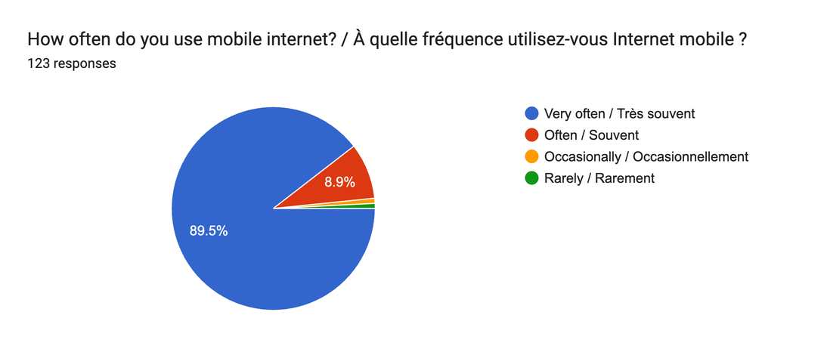
Figure 1:Questionnaire1

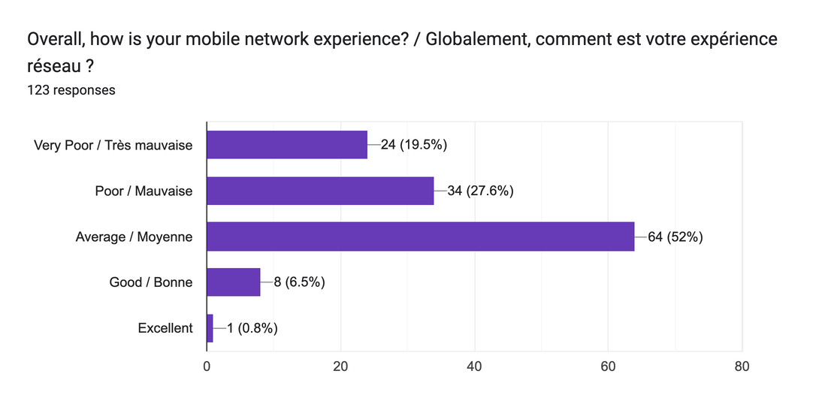
Figure 2:Questionnaire2
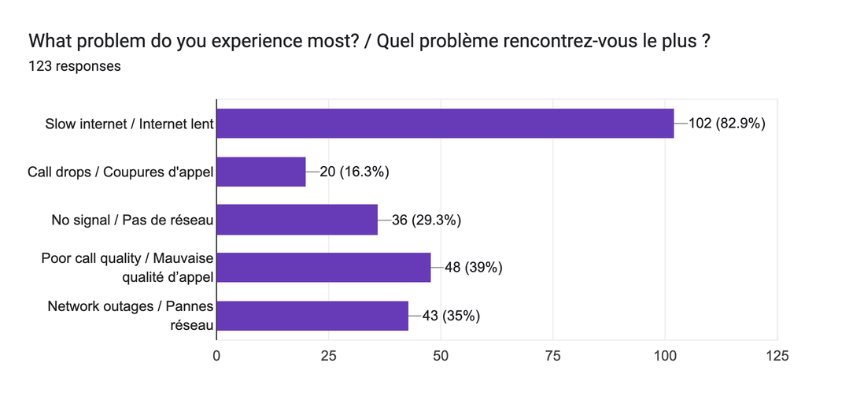
Figure 3:Questionnaire3(frequency of problem)
These findings highlight a significant mismatch between user dependence on mobile networks and the quality of service experienced.
Key Challenges Faced by Users:
- Frequent slow internet speeds
- Unstable connections and service interruptions
- Poor overall reliability of network services
- Limited visibility into the cause of network issues
User Needs:
- Improved and consistent network performance
- A platform to report and monitor their network experience
- Greater transparency regarding network quality
- A lightweight and non-intrusive solution that does not heavily impact battery or data usage
2.1.2 Network Service Providers (MTN, Orange, Camtel)
- Network service providers are secondary stakeholders, as they are responsible for delivering network services and would potentially utilize the insights generated by the proposed system to improve service quality.
- From the survey data, MTN is the dominant provider among respondents, accounting for 87% of users, followed by Orange (38.2%) and Camtel (16.3%). This indicates that any proposed solution should be scalable and relevant to major providers, particularly MTN.
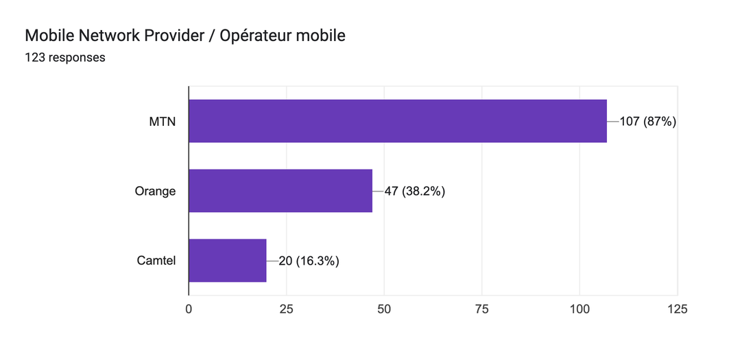
Figure 4:Questionnaire4(most used network service provider)
An interview conducted with A senior manager in the technology department of MTN provided additional insight into the provider’s perspective. It was confirmed that MTN already performs real-time network monitoring and has mature systems for managing network performance and service quality. However, access to detailed operational data is restricted due to confidentiality and security requirements.
While these systems provide strong technical monitoring (Quality of Service, QoS), they do not fully capture the real-time, contextual experience of users from a human perspective. Additionally, the confidentiality of internal data limits external visibility into user complaints and detailed performance metrics.
Key Challenges Faced by Providers:
- Difficulty in accessing real-time, user-specific experience data at scale
- Limited ability to directly correlate user perception with network performance metrics
- Data confidentiality and security constraints
Provider Needs:
- More granular and user-centered QoE data
- Context-aware insights (location, time, usage type)
- Tools that complement existing monitoring systems without compromising security
This stakeholder analysis demonstrates that while users experience significant network challenges, providers already possess strong technical monitoring capabilities. The gap between these two perspectives reinforces the need for a system that bridges technical network data and experience.
Upon export, the raw dataset (120 responses) presented five issues: exposed email addresses (privacy risk), bilingual English/French response values, verbose bilingual column headers, a duplicate question column, and multi-select responses concatenated into single cells. These were resolved through five cleaning steps: respondent anonymization (User_1–User_120), column header standardization, extraction of English-only text using Excel's TEXTBEFORE function, removal of the duplicate column, and a multi-response percentage method for multi-select questions. No responses were deleted at any stage.
The cleaned dataset is organized across four worksheets; Raw Data, Clean Data, Processed Data, and Summary to preserve traceability from raw export through to final analysis.

2.5 Key Insights from the Data
Analysis of the 120 cleaned responses produced nine key insights that directly inform system design:
- High dependence on mobile internet: 89.4% of users rely on it very often for social media, messaging, work, and browsing.
- Poor user experience despite high usage: only 6.6% rated their experience good and 0.8% excellent, versus 51.6% average, 27.9% poor, and 19.7% very poor.
- Slow internet is the dominant issue (82.9%), followed by poor call quality (39%), outages (35%), and lack of signal (29.3%).
- Network problems are frequent and widespread: 69% of users experience issues often or very often, and 60.7% report issues occurring everywhere rather than at specific locations.
- Performance degrades most during high-usage periods, particularly afternoon (48.4%) and evening (33.6%), suggesting congestion effects.
- Streaming highlights QoE issues: roughly 54% report videos buffering often or always.
- Strong willingness to adopt a solution: 84.6% would use a network-monitoring app, and 76% would allow automatic data collection.
- Privacy and trust are major concerns: privacy (65.9%), data usage (60.2%), security (55.3%), and battery consumption (38.2%).
- Users prefer context-aware, event-based feedback prompts (46.8%) rather than fixed-interval requests.

2.6 User Reluctance Assessment
Both users and providers show reluctance toward data sharing, though for different reasons: users are concerned about privacy, cost, and device performance, while providers are concerned about security, confidentiality, and control of internal data. These findings imply that the proposed system must ensure transparency, use minimal device resources, protect user identity through anonymization, and clearly communicate the value of participation.

2.7 Summary of Findings
The requirement gathering process confirms that mobile network operators possess strong technical monitoring capabilities (QoS) but lack real-time, contextual, user-driven Quality of Experience (QoE) data, resulting in an incomplete understanding of actual service quality. This finding establishes the foundation for the requirement analysis and Software Requirement Specification presented in Chapter 3.

CHAPTER 3: REQUIREMENT ANALYSIS

3.1 Introduction to Requirement Analysis
Building on the raw findings from Chapter 2, a Google Forms survey (121 valid responses), an MTN technology staff interview, a team brainstorming session, and reverse engineering of existing apps including Speedtest by Ookla, OpenSignal, and MyMTN. This chapter transforms those findings into structured, validated, and prioritized system requirements that drive the design of the QoE data collection mobile application.

3.2 Review and Analysis of Gathered Requirements

3.2.1 Completeness of Requirements
- User perspective: captured through 121 survey responses focusing on network experience, pain points, and app acceptability.
- Operator perspective: captured through the MTN interview, revealing existing network-side data and remaining gaps.
- Privacy and adoption concerns: covered through survey questions on battery drain, data usage, and notification preferences.
- Competitive landscape: covered through reverse engineering, confirming no existing Cameroonian app combines passive background monitoring with active subjective feedback collection.

3.2.2 Clarity of Requirements
Ambiguous survey feedback was interpreted and grouped into specific requirements. For example:
- Vague complaints such as "very poor network experience" were decomposed into specific issues: latency, bandwidth degradation, and signal instability.
- Requests for feedback "once a day" or "when there's a problem" were interpreted as a requirement for configurable feedback prompt frequency.
- Concerns about data sharing were split into two distinct requirements: data anonymization and user consent management.

3.2.3 Technical Feasibility: Platform Decision
The application targets Android exclusively. iOS imposes restrictions incompatible with the system's core requirements: Apple does not expose telephony APIs for signal strength or network type to third-party developers, and iOS does not support persistent background services comparable to Android's Foreground Service. Existing apps such as Speedtest by Ookla work on iOS only through active, user-triggered sessions, which differs fundamentally from the continuous passive monitoring this system requires. Survey data also confirmed that Android dominates the Cameroonian smartphone market due to affordability and reach across rural and urban areas, further supporting this decision.

3.2.4 Feature-Level Feasibility Summary
Feature | Difficulty | Key Tool/Package | Main Risk
Background Monitoring | Medium | WorkManager and Foreground Service | OEM battery killing on some devices
Network Metrics Collection | Medium | Telephony Manager API | Permission sensitivity on newer Android
Network Type Detection | Easy | Connectivity Manager and Telephony Manager | Minimal
Local Data Storage | Easy | Room Database (Kotlin) | Storage clean-up scheduling
Backend Synchronization | Easy | Retrofit and Supabase REST API | Duplicate upload handling
User Dashboard | Easy–Medium | Jetpack Compose and MPAndroidChart | UI complexity management
Operator Reports | Medium | Supabase SQL views | Scope expansion risk

Background monitoring runs via Android's Foreground Service, mitigated against aggressive battery optimization by guiding users to whitelist the app. Network metrics (signal strength in dBm, network type, and latency) are collected via TelephonyManager; packet loss and jitter are deferred to a later version. Feedback prompts are event-triggered (e.g., signal drop, network downgrade, latency spike, or call end) rather than fixed-interval, reducing notification fatigue, and are scheduled reliably via WorkManager. All data follows an Offline-First model: written locally to Room Database first, then synchronized to Supabase over WiFi by default to conserve mobile data, with duplicate uploads prevented via unique record IDs. A user-facing dashboard (MPAndroidChart) shows personal QoE history, while operator-facing reports expose only anonymized, aggregated summaries.

3.2.5 Dependency Relationships
Requirement | Depends On
QoE feedback collection | User interaction and notification permission
Background network monitoring | Battery optimization exemption granted by user
Network metrics accuracy | READ_PHONE_STATE and ACCESS_NETWORK_STATE permissions
Cloud analytics | Successful data synchronization to Supabase
Privacy protection | Data anonymization layer applied before any upload
Operator reports | Sufficient data volume from active users

3.3 Identification of Inconsistencies and Missing Information

Inconsistencies Found
Inconsistency 1: Signal vs Experience Mismatch: some respondents reported moderate signal strength yet rated their overall experience as poor, showing that good signal does not guarantee good QoE and reinforcing the need to collect both objective metrics and subjective ratings together.
Inconsistency 2: Operator Monitoring vs User Complaints: the MTN interview confirmed monitoring tools are already in place, yet 89.4% of users reported widespread poor experience, confirming that existing QoS monitoring does not capture what subscribers actually feel.

Missing Information
The following data points were not captured during requirement gathering but will be automatically collected by the app during operation:
- Real-time signal strength readings at the moment of degradation.
- Network type at the time of poor experience (2G, 3G, or 4G).
- Precise timestamps correlated with network metric drops.
- Device metadata including Android version and phone model.
- Long-term usage behaviour patterns observed over days and weeks.

3.4 Requirement Prioritization
Priority | Requirement | Justification
High | Real-time QoE feedback collection | Core purpose of the system
High | Passive background network monitoring | Distinguishes the app from all existing solutions
High | User privacy and data anonymization | Critical for user trust and adoption
High | Low battery and data consumption | Top concern raised by surveyed users
Medium | Time-of-day degradation analysis | Enhances insight quality for operators
Medium | Usage-type pattern analysis | Adds context to QoE ratings
Low | Advanced operator analytics export | Phase-two feature after sufficient data volume

3.5 Requirement Classification

Functional Requirements
- Collect subjective QoE ratings periodically across overall satisfaction, response time, and usability.
- Automatically capture objective network metrics in the background, such as signal strength, network type, and latency.
- Record a timestamp with every data point collected.
- Store all collected data locally on the device when offline.
- Synchronize stored data to the remote Supabase backend when connectivity is available.
- Prompt users for feedback at configurable intervals via local notifications.
- Allow users to manually submit a network experience rating at any time.
- Display a personal QoE history and trend dashboard to the subscriber.
- Provide anonymized, aggregated network experience reports to operators.

Non-Functional Requirements
- Performance: the background service must consume minimal CPU and RAM at all times.
- Battery efficiency: data collection must not cause noticeable battery drain; backend sync defaults to WiFi only.
- Privacy: all personally identifiable information must be anonymized before leaving the device.
- Security: all data transmission must use HTTPS; backend access is controlled through Supabase Row Level Security.
- Reliability: the app must continue collecting data offline and sync automatically once connectivity is restored.
- Usability: feedback prompts must be completable in under 30 seconds to minimize user effort.
- Scalability: the backend must handle data from a growing number of concurrent users across Cameroon.

3.6 Software Requirement Specification (SRS) Overview

System Overview
The system is a mobile application enabling real-time, continuous collection of both subjective user QoE feedback and objective network performance metrics from mobile subscribers in Cameroon. It runs passively in the background while periodically prompting users for experience ratings, bridging the gap between network-side QoS monitoring and actual subscriber experience.

Data Architecture: Offline-First with Cloud Sync
The system follows an Offline-First architecture to guarantee data integrity in unreliable network environments. The data flow proceeds as follows:
- A trigger event fires, either network-side or user-side.
- Network metrics are collected immediately from TelephonyManager and ConnectivityManager.
- Metrics and feedback ratings are saved to the local Room Database with a unique record ID and an is_synced flag set to false.
- When connectivity is available, the app anonymizes records by stripping personally identifiable fields and uploads them to Supabase via Retrofit.
- Supabase confirms receipt and the local record is marked as synced.
- Records older than 7 days that are confirmed synced are automatically purged from local storage.
Operators access data exclusively through aggregated Supabase views — average scores, trend patterns, and network type distributions — and never interact with raw individual records.

Privacy Alignment
User Privacy Concern | How Architecture Addresses It
I don't want my data shared | Only anonymous, non-identifiable data leaves the device
Who owns the data? | The user owns device data; only aggregates reach operators
Can operators use it against me? | Operators see trends only, never individual identities
What if the app is compromised? | The local database is encrypted; no sensitive fields are stored
I want to stop participating | Users can pause collection or delete local data at any time

Scalability Consideration
Local storage on individual devices scales independently of total user count, and the Supabase backend comfortably handles pilot-scale deployment. For regional or national scale, the backend would require database indexing, partitioning by date or region, and a dedicated analytics pipeline, identified as Phase 2 infrastructure considerations.

Inputs, Outputs, and System Users
Inputs:
- User satisfaction ratings covering overall experience, response time, and usability.
- Signal strength and network type (2G/3G/4G).
- Latency measurements.
- Device metadata, including Android version and phone model.
- Timestamps of all collected data points.
Outputs:
- Personal QoE history and trend chart for the subscriber.
- Time-of-day network quality patterns.
- Aggregated, anonymized QoE reports for operators.
- Usage trend analytics across the subscriber base.
System Users:
- Subscribers: install the app, provide feedback, and view personal QoE history.
- Network Operators (MTN/Orange): view and use aggregated anonymized QoE reports.
- Administrators/Developers: manage the backend and monitor data integrity.

3.7 Requirement Validation with Stakeholders
Subscribers: survey results confirm strong validation, with 89.4% of users heavily dependent on mobile data yet predominantly rating their experience as poor or very poor. A significant majority expressed willingness to install the app provided battery drain and privacy concerns are addressed, both captured as high-priority non-functional requirements.
Network Operators: the MTN interview confirms subscriber-side QoE data is currently unavailable to operators, and that real-time aggregated feedback would directly support network planning. The system complements rather than duplicates existing QoS infrastructure, strengthening the case for operator partnership.
Both validations confirm the system addresses a real, documented problem with strong likelihood of adoption from both sides.

3.8 Summary of Requirement Analysis
- All gathered requirements are feasible within the native Android platform using Kotlin, WorkManager, Room Database, Retrofit, and Supabase.
- The core problem: high mobile data usage with persistently poor subscriber experience is empirically validated by survey data.
- User adoption is likely, provided battery efficiency and privacy are prioritized throughout implementation.
- The system is unique within Cameroon, as no existing app combines continuous background monitoring, active feedback collection, and local operator integration.
- Key missing data points, such as real-time signal readings and timestamps, will be automatically captured by the app itself during operation.
- Android-only targeting is a deliberate technical decision grounded in platform capability and market share.

CHAPTER 4: SYSTEM MODELLING AND DESIGN
System modelling and design translated the requirements established in the SRS into a formal visual representation of the netLink system across six standard UML diagrams. Together these diagrams define the system from its highest level of external abstraction down to its physical deployment architecture, providing the complete design blueprint from which the application was built.

1.The Context Diagram:
The Context Diagram presents the entire netLink system as a single process and defines its boundary by showing all external entities that interact with it and the data that flows between them. Four external entities surround the central QoE Monitoring System process: the Mobile Subscriber who submits ratings and receives prompts and dashboard output, Android System APIs which supply signal strength, network type, call state and connectivity events, the Network Operator who receives aggregated QoE reports and sends analysis queries, and the Supabase Backend which receives anonymized synchronized records and returns upload confirmations. The diagram establishes what data enters and exits the system without revealing any internal logic.
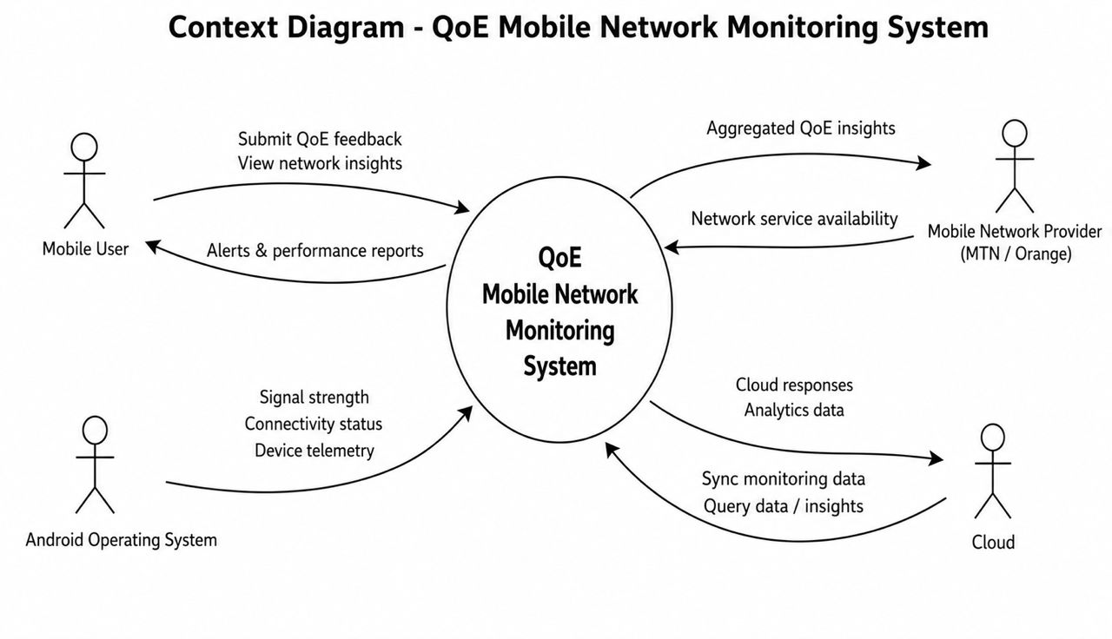
Figure 5:context diagram

2. Dataflow Diagram
The Level 0 Dataflow Diagram opens the single context process and reveals five internal processes. Process 1 collects network metrics from Android APIs. Process 2 collects user feedback ratings from the subscriber. Process 3 manages local data storage in D1 , the on-device Room Database applying sync flags and enforcing the seven-day retention policy. Process 4 handles data synchronization, fetching unsynced records from D1, anonymizing them and uploading to D2, the Supabase cloud database. Process 5 serves analytics and dashboard output, delivering personal QoE history to the subscriber and aggregated reports to the operator. A core rule governs the diagram: data never flows directly between two data stores, it must always pass through a process.
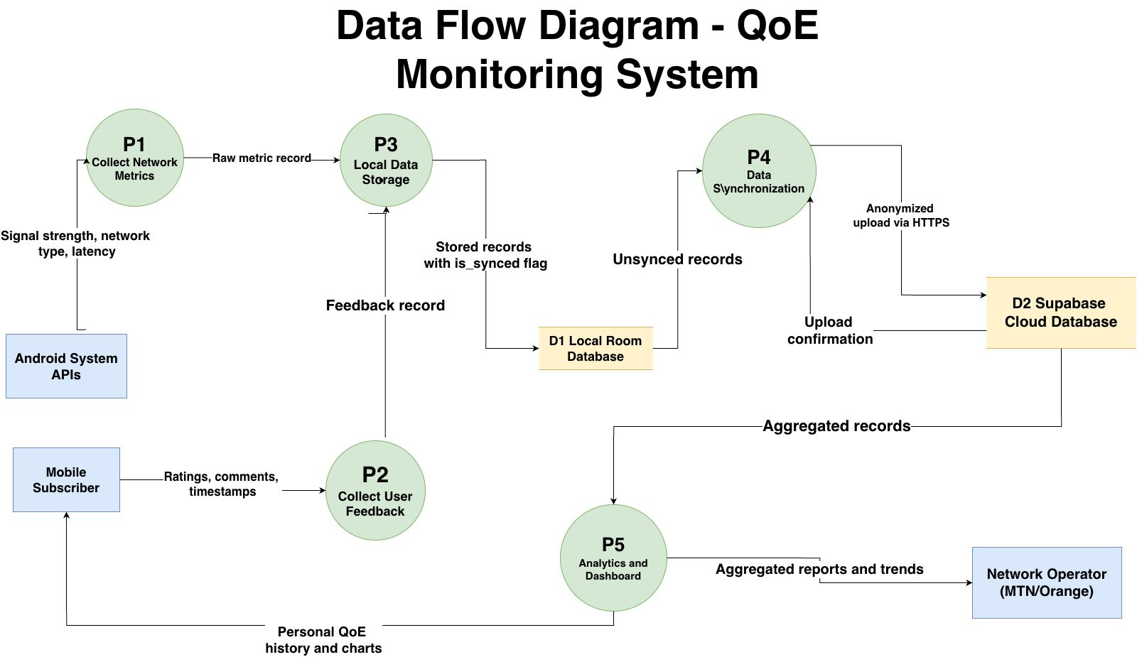
Figure 6:Dataflow diagram

3. Use Case Diagram
The Use Case Diagram defines all interactions between actors and the system from the user perspective. Four actors participate: the Mobile Subscriber as the primary actor with nine use cases covering the complete journey from onboarding through monitoring, feedback and settings management; the Android System as a secondary automated actor with five use cases covering background metric collection, event detection and synchronization; the Network Operator with three use cases covering report viewing, trend analysis and data export; and the Administrator with two use cases covering backend management and data integrity monitoring. Key relationships include associations such as:
- Complete Onboarding including Grant Permissions
- extend associations such as Detect Degradation extending Trigger QoE Prompt only when a threshold is crossed.
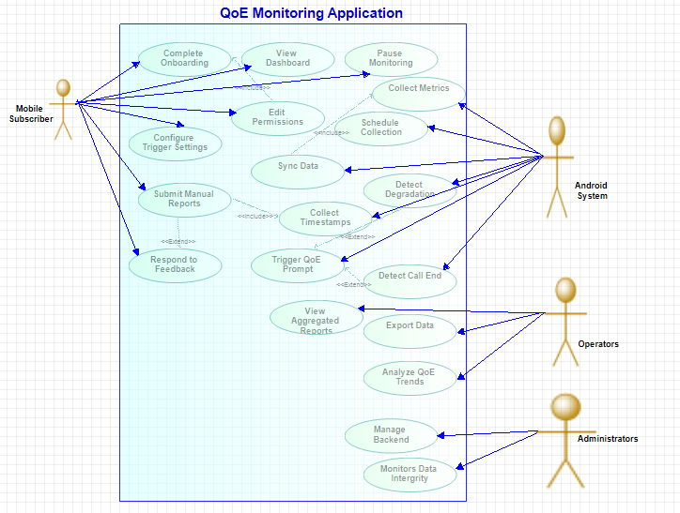
Figure 7:Use case diagram

4. Sequence Diagrams
Two sequence diagrams capture the most critical operational flows. The first covers event-triggered feedback collection: a signal drop is detected by BroadcastReceiver, metrics are collected from Android APIs, a NetworkMetric record is saved to Room, a notification prompts the subscriber, the subscriber submits a rating, the feedback record is saved linked to the metric via networkMetricId, and the records are synchronized to Supabase if WiFi is available. The second covers background periodic monitoring: WorkManager fires every thirty minutes, metrics are collected and evaluated against thresholds, a feedback prompt is triggered if a threshold is exceeded or the record is saved silently if conditions are normal, and synchronization follows if connectivity allows. Both diagrams use alt fragments to make the conditional WiFi and threshold logic explicit.
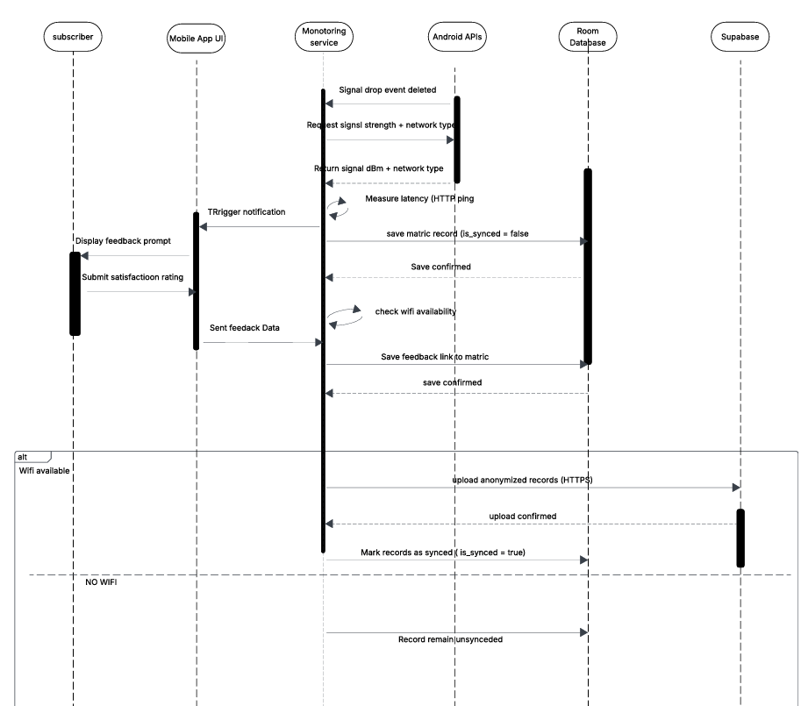
Figure 8:sequence diaram

5. Class Diagram
The Class Diagram defines the static structural architecture of the system across three layers. The Data layer contains the NetworkMetric and QoEFeedback entities, the AppConfiguration data class, and the QoERepository as the single gateway between all other classes and the local database. The Domain layer contains NetworkMonitoringService as the persistent Foreground Service, EventDetector which evaluates metrics against thresholds, FeedbackManager which builds and dispatches prompts, and SyncManager which manages the upload lifecycle. The Presentation layer contains DashboardManager serving both subscriber history and operator analytics views. An inheritance hierarchy places User as the parent class with Subscriber, Operator and Administrator as child classes, each inheriting base identity attributes while adding role-specific attributes and methods. Two previously missing dependency arrows EventDetector notifying FeedbackManager and SyncManager depending on QoERepository were identified and corrected during the review phase.
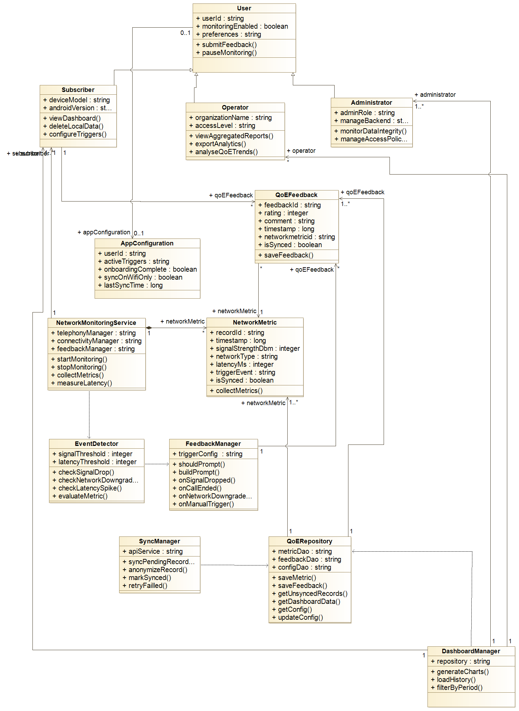
Figure 9:class diagram

6. Deployment Diagram
The Deployment Diagram maps all software components to four physical nodes. Node 1 is the Subscriber Android Device hosting the netLink APK, Foreground Service, WorkManager Tasks, BroadcastReceiver, Jetpack Compose UI and the encrypted local Room Database. Node 2 is the Android System Services layer on the same physical device, exposing TelephonyManager, ConnectivityManager, NotificationManager and WorkManager Scheduler to the application through the Android SDK. Node 3 is the Supabase Cloud Backend hosting the REST API layer, PostgreSQL database, aggregated operator views, Row Level Security policies and Supabase Auth. Node 4 is the Operator Access Point a web browser or admin dashboard with a read-only database role. The most architecturally significant element of this diagram is the deliberate absence of a direct connection between the Operator Access Point and the Android Device, which physically represents the privacy architecture: operators access only Supabase, never the subscriber's device.
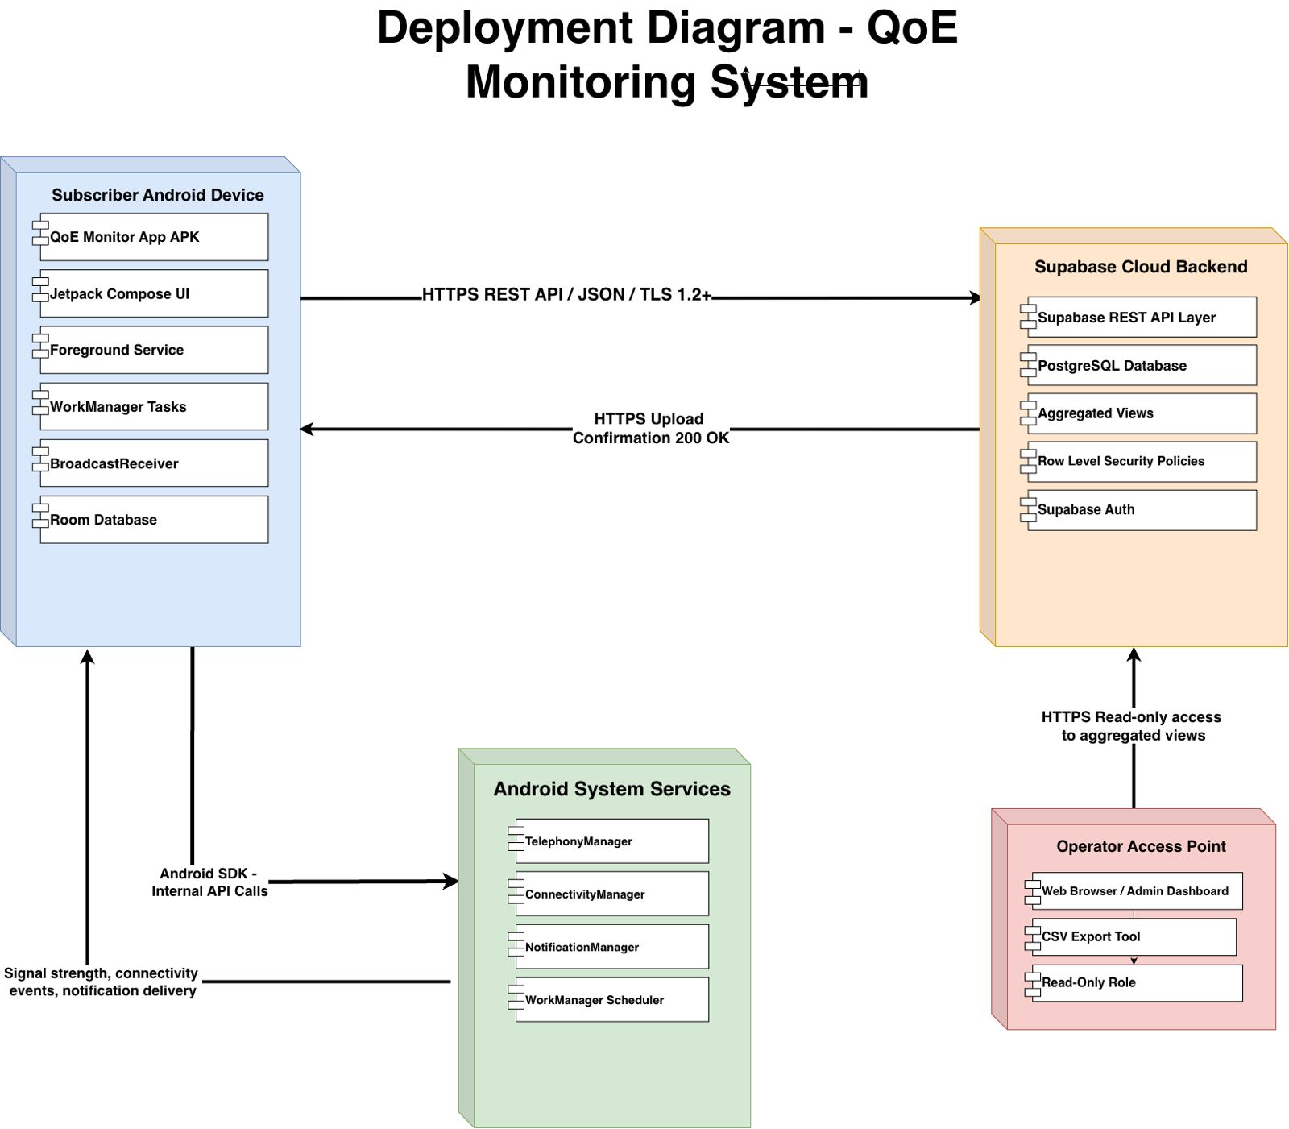
Figure 10:Deployment diaram

CHAPTER 4: APP IDENTITY AND VISUAL DESIGN
Building on the validated requirements of Chapter 3, this chapter presents the brand identity and visual design system created for the application, now named netLink. It covers the naming rationale, logo, colour philosophy, design principles, and the screen-by-screen interface used across onboarding, the dashboard, feedback, history, and settings.

4.1 App Identity
The application is named netLink, written in lowercase-camel style to signal approachability while the capitalized "Link" conveys its core value: connecting subscribers to a transparent view of their own network quality. The name was chosen for being pronounceable in both English and French, operator-neutral (avoiding association with MTN or Orange), and self-explanatory to a Cameroonian audience.
The logomark is a stylish signal arc (three concentric curves) with a filled circle anchor representing the subscriber's device, rendered in Forest Teal (#0D6B5E) with a Living Coral (#E8593A) accent. The colour system centres on three tokens: Forest Teal as the primary identity colour, Living Coral for calls to action and alerts, and Warm Cream (#F5F7F6) as a non-clinical background colour. This palette was deliberately chosen to avoid MTN's yellow and Orange's orange, keeping the app visually independent.
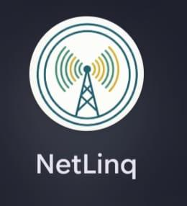
Figure 11:Netlinq logo for dark mode

4.2 Visual Design Principles
Five design rationales guide the interface, aimed at lowering participation barriers and building user trust:
- Anonymous onboarding replaces login screens entirely: no names, emails, or passwords, only a short device-ID preview.
- Plain-language communication replaces technical terms (e.g. "latency" becomes "Speed", raw dBm values become "Strong/OK/Weak").
- Dual feedback paths separate quick single-tap ratings triggered by network events from a detailed 5-category form used voluntarily.
- Every feedback submission is linked to a snapshot of the network metrics recorded at that moment, preserving data integrity for operators.
- The subscriber-facing app is stripped of all developer/preview tools, keeping advanced analytics on a separate operator dashboard.

4.3 Colour Tokens and Typography
The palette is organized into brand, neutral, and semantic tokens, summarized below.
Token | Value | Use
TealPrimary | #14B8A6 / #0D6B5E | Buttons, icons, active accents
Slate900 / Slate50 | #0F172A / #F8FAFC | Dark/light mode backgrounds
Quality: Good / Fair / Poor | #22C55E / #F59E0B / #EF4444 | Signal and rating indicators

Typography uses Android's default Roboto family at scalable sizes (sp) for accessibility, ranging from 32sp Bold for headline text down to 12sp for captions and navigation labels. Layouts use 20–24dp side gutters, 16–20dp vertical spacing, 20dp card corner radius, and 36–40dp touch targets for star ratings.

4.4 Screen-by-Screen Design
The interface comprises six screen groups: a 5-step onboarding wizard (welcome, how-it-works, consent, permissions, ready), the Network Dashboard, the detailed Feedback form, the QoE History screen with trend charts, event-triggered Quick Rating prompts, and Settings for monitoring/sync/trigger controls. Representative screens are shown below.
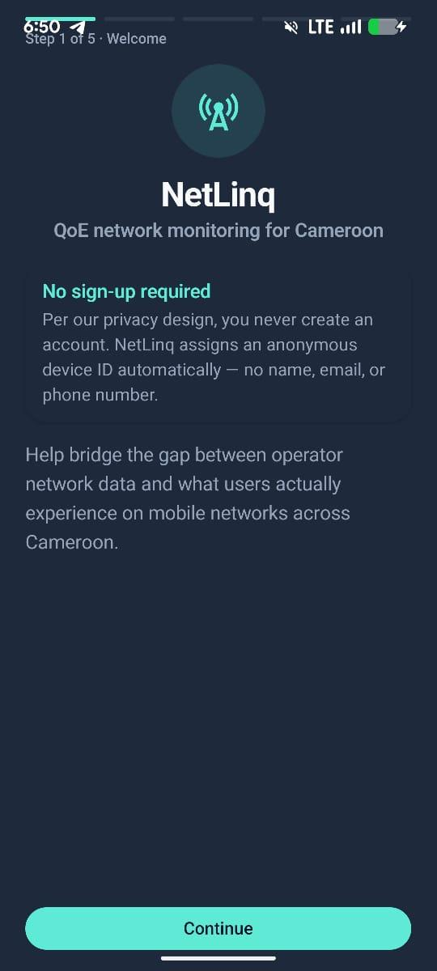
Figure 12:Onboarding screens

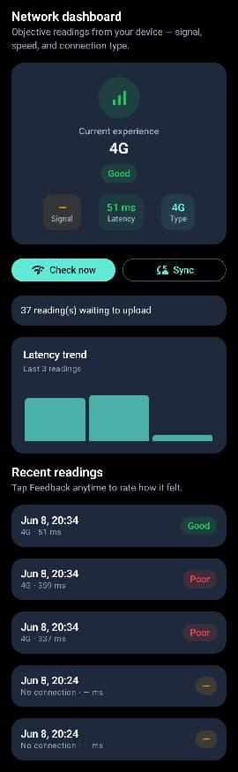
Figure 13:Network Dashboard showing live signal, latency, and connection type.

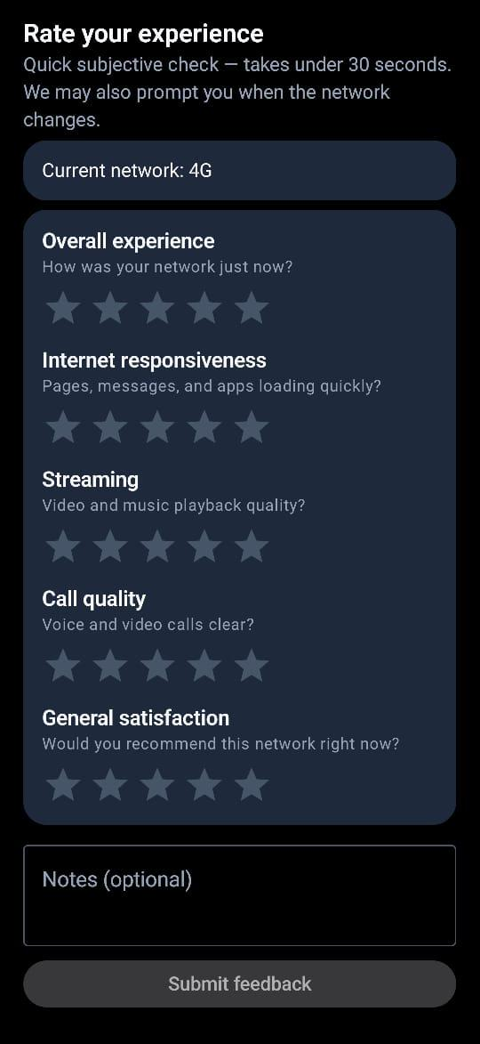
Figure 14:Detailed Feedback form with five star-rating categories and text feedback
.
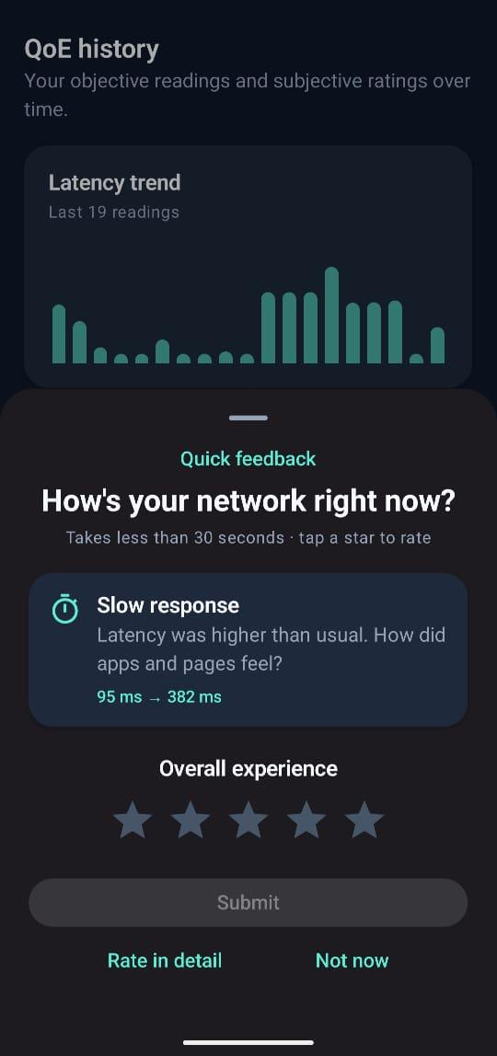
Figure 15:QoE History screen with latency trend and quick-feedback prompt.

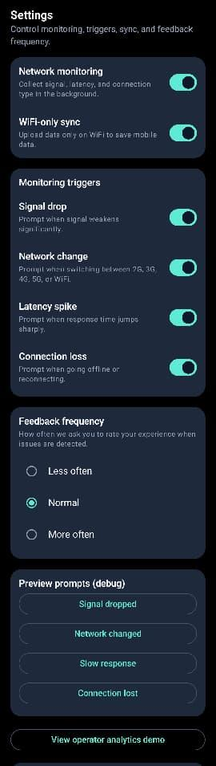
Figure 16:Settings screen controlling monitoring, triggers, and sync.

CHAPTER 5: FRONTEND IMPLEMENTATION
The visual design of Chapter 4 was implemented as a native Android application in Kotlin using Jetpack Compose, following an MVVM and Clean Architecture pattern. This chapter summarizes the composable structure, state management, navigation, and how domain models map to the UI.

5.1 Composable Structure
The UI layer is built entirely from declarative Kotlin composable functions rather than XML layouts. MainScaffold.kt manages the global application frame and theme switching, while a bespoke bottom navigation bar (NetLinqBottomBar) hosts four tabs: Dashboard, History, Feedback, and Settings, using teal accents in place of default Material styling.

5.2 State Management (MVVM)
The architecture separates Presentation, ViewModel, Domain, and Data/Monitoring layers. Composable screens (HomeScreen.kt, HistoryScreen.kt, SettingsScreen.kt) observe state exposed by ViewModels (MainViewModel.kt, PromptEventViewModel.kt) as lifecycle-aware StateFlow streams via collectAsState(). ViewModels in turn read domain models (NetworkMetric, QoeFeedback, FeedbackNetworkLink) backed by Room, DataStore, and the Supabase API. Composables are kept stateless where possible, receiving immutable state and passing user actions up via lambdas to conserve battery and memory.

5.3 Navigation and Routing
Screen destinations are defined programmatically in NetLinqNavGraph.kt. At launch, the app checks a DataStore onboarding flag; if incomplete, it routes the user through the 5-step onboarding flow and clears those screens from the back stack afterward. Background monitoring triggers use Android intent extras to deep-link a tapped notification directly to a pre-populated feedback panel for the relevant network reading.

5.4 Domain-to-UI Mapping
- NetworkMetric readings (collected via TelephonyManager) feed the MetricStatChips component, translating raw values into plain labels such as Strong, OK, or Weak.
- QoeFeedback captures the five rating categories; FeedbackScreen.kt keeps the submit button disabled until all five are rated.
- FeedbackNetworkLink connects each rating to the exact signal snapshot at submission time, read by HistoryScreen.kt to display context-rich history entries.
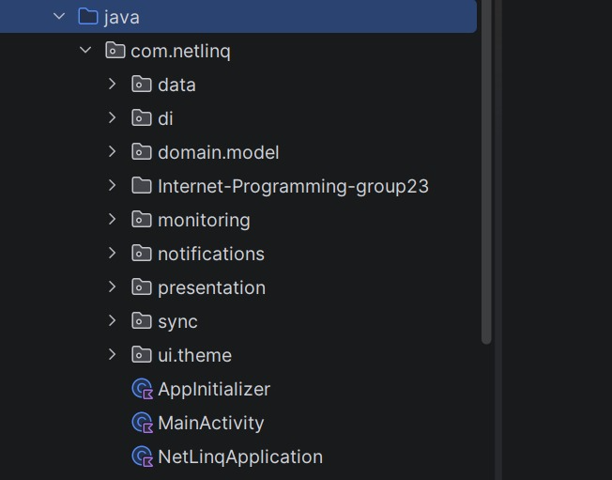
Figure 17;MVVM Architecture showin presentation layer for mobile subscriber frontend

5.5 Operator Dashboard.
The admin frontend provides a centralized web interface that enables administrators to monitor user reports, view network analytics, and manage system data through a clean, responsive, and user-friendly dashboard. It serves as the primary interface for system administration and oversight.
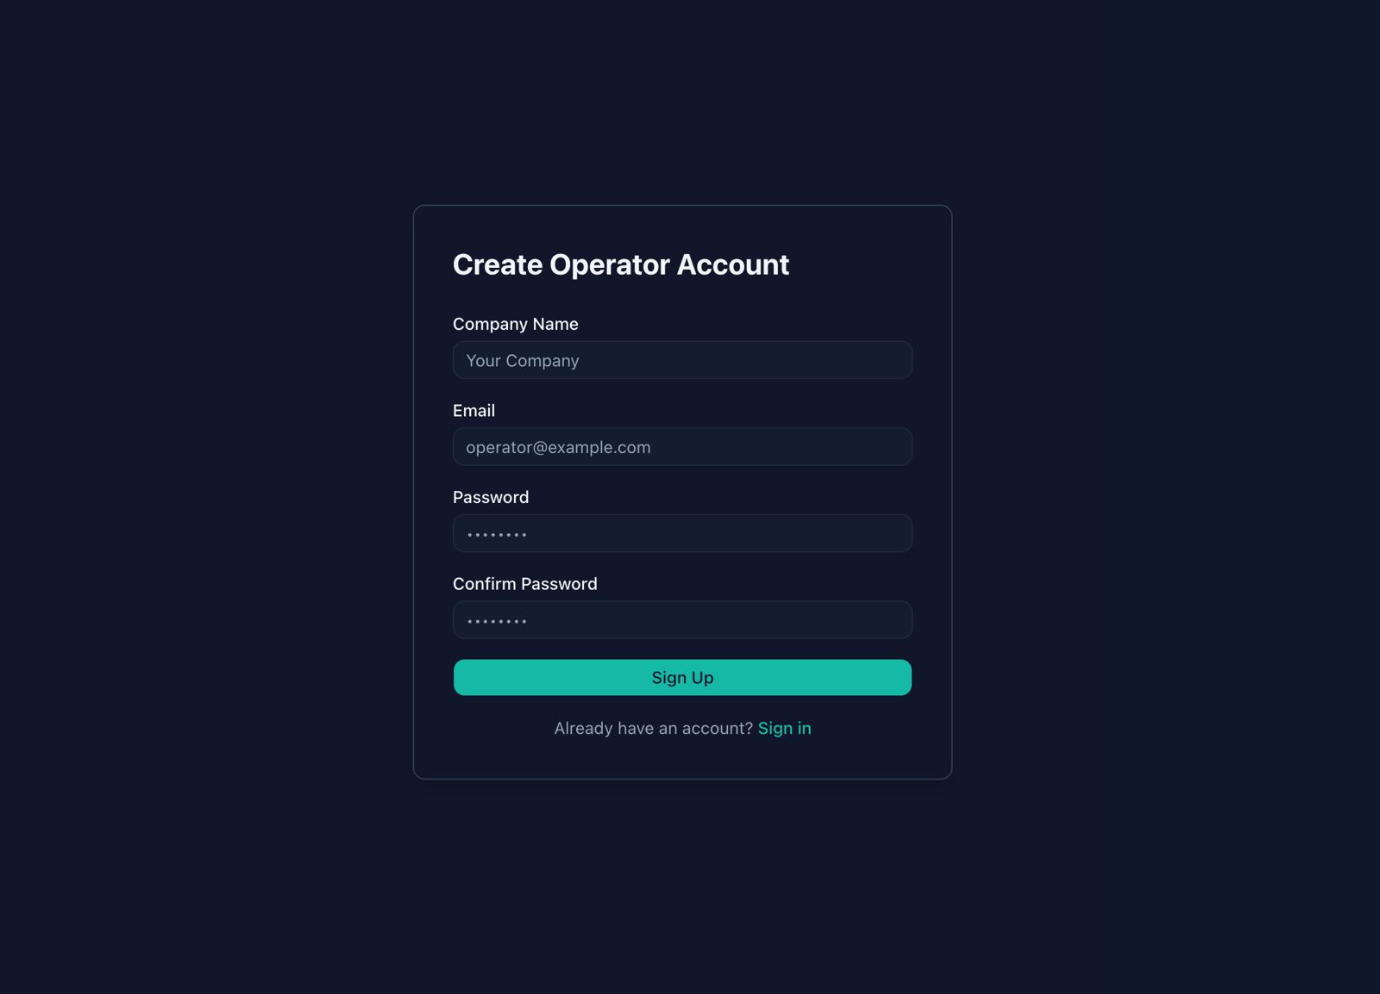
Figure 18:operator sinup
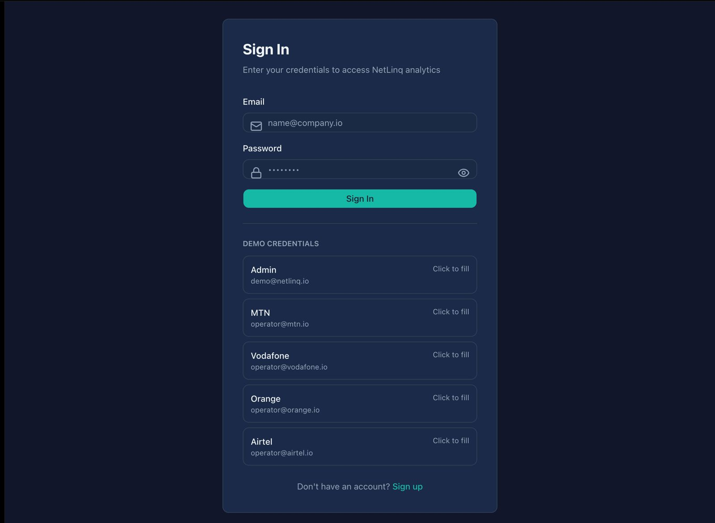
Figure 19:Operator loin
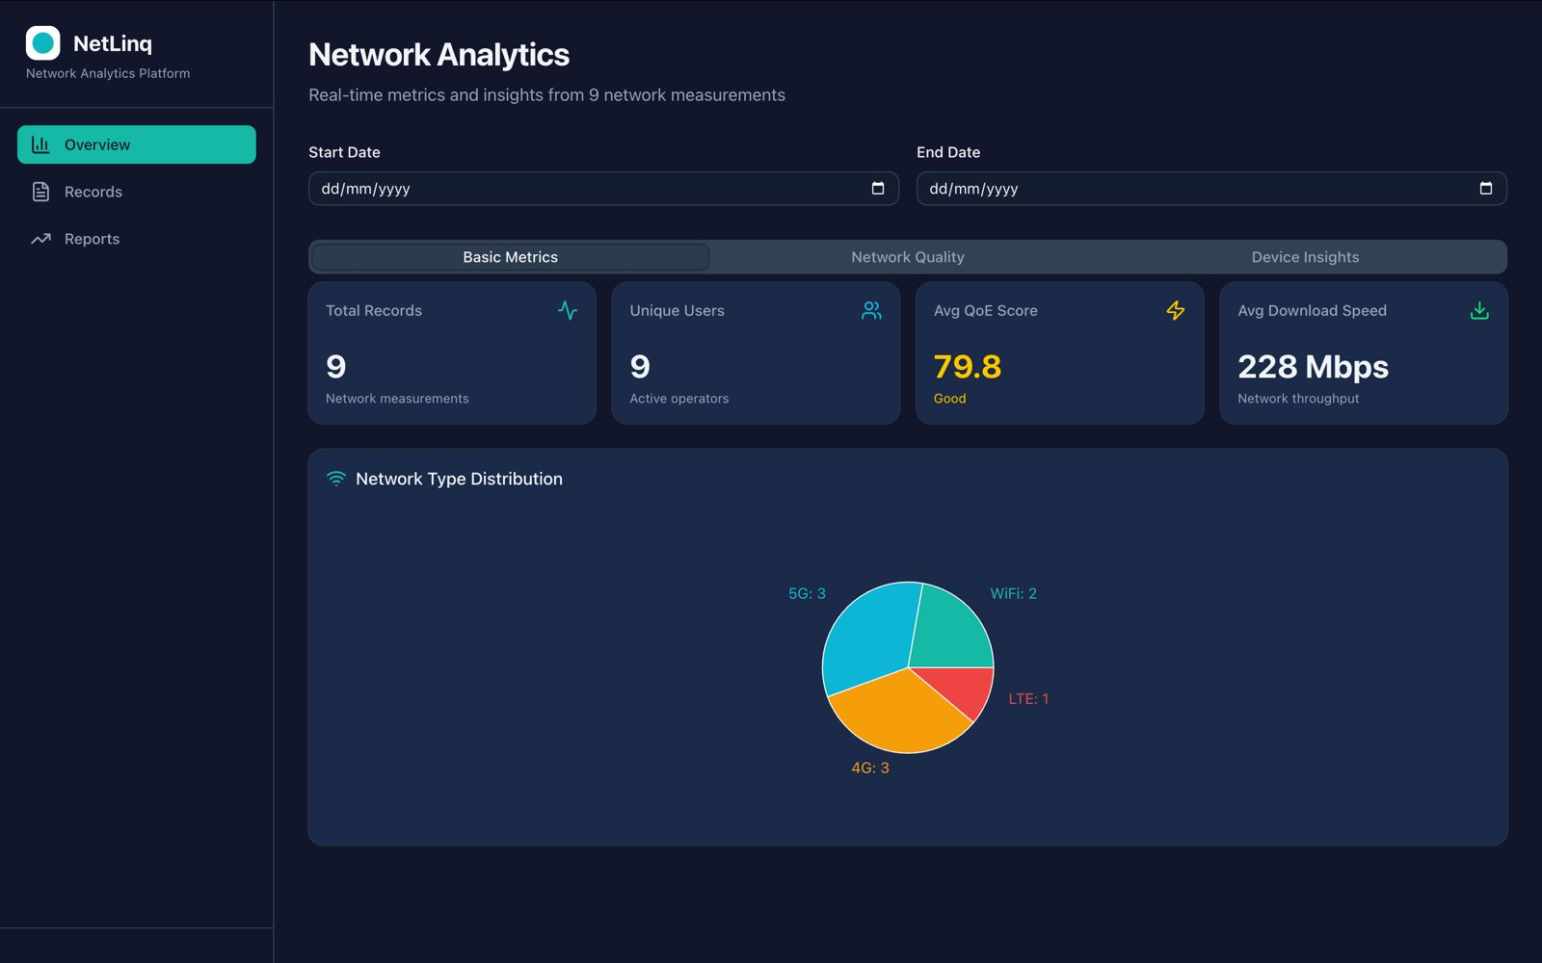
Figure 20:Operator Dashboard

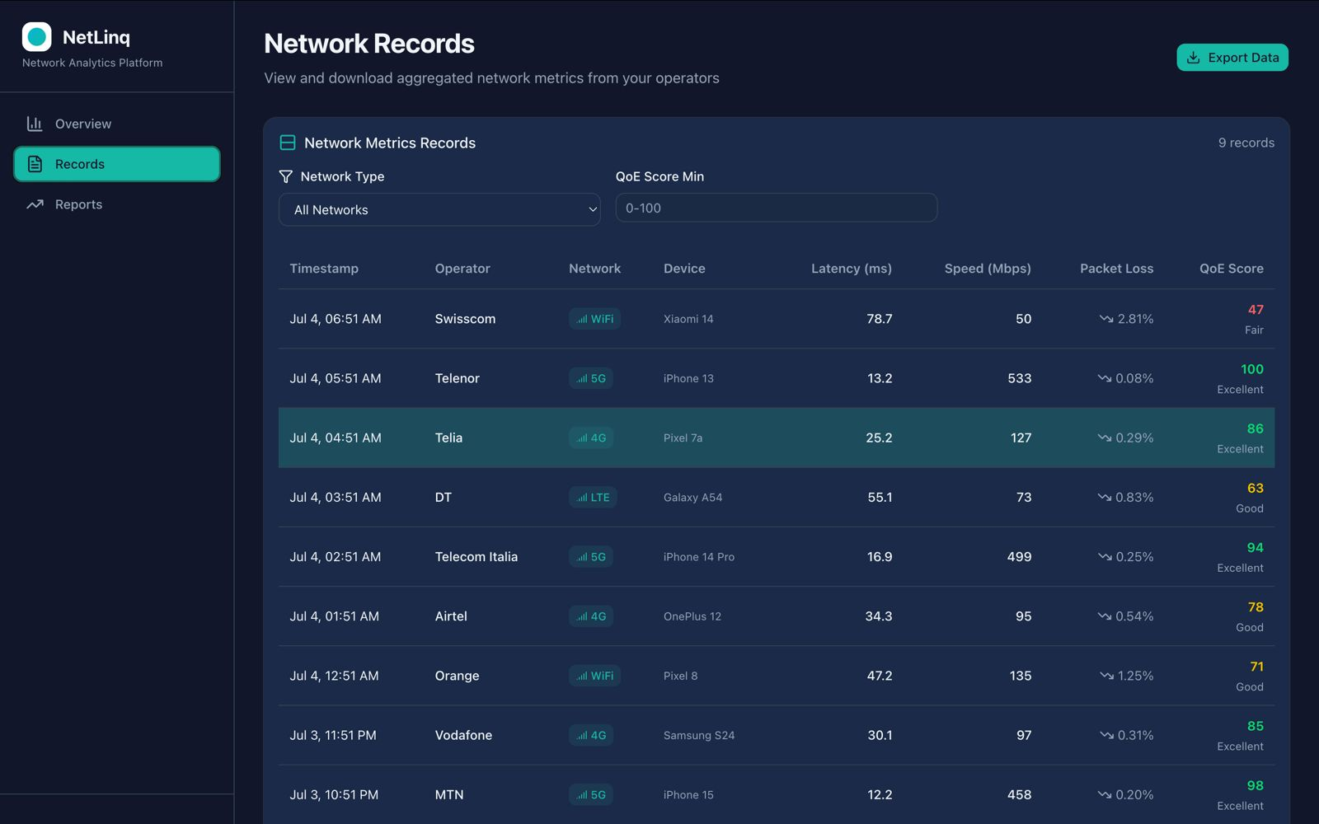
Figure 21:Network trends and records
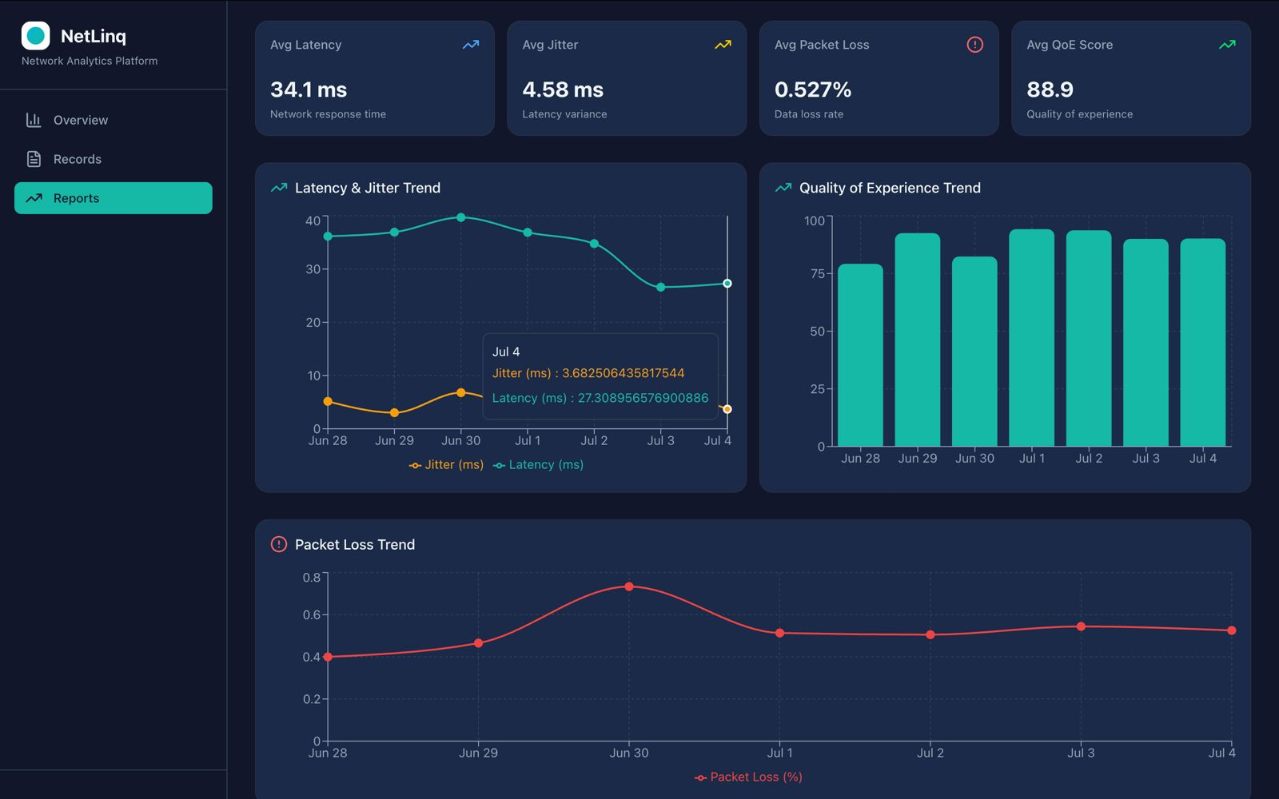
Figure 22:Network metrices trends

CHAPTER 6: DATABASE DESIGN AND BACKEND IMPLEMENTATION
This chapter documents the data layer that powers netLink: the entities stored, the conceptual and physical database design, and the backend code that collects, persists, and synchronizes data between the device and the cloud.

6.1 Data Elements
Four core entities are stored across two tiers: on-device Room storage and a Supabase (PostgreSQL) cloud backup.
Entity | Description | Stored Where
Network Metric | One automatic reading: signal, network type, latency, device info, timestamp | Room + Supabase
QoE Feedback | User star ratings (5 categories) plus optional link to a reading | Room + Supabase
Device Identity | Random UUID on device; SHA-256 hash uploaded as device_hash | DataStore + Supabase (hash only)
App Preferences | Monitoring on/off, sync settings, trigger toggles | DataStore (local only)

Ratings are constrained to 1–5 (enforced via Supabase CHECK constraints), no personally identifying data is stored in the cloud, and synced rows older than 7 days are purged locally while cloud data is retained.

6.2 Conceptual Design
The design follows an offline-first, privacy-first model: the phone is the source of truth while offline, and the cloud serves as backup and analytics. One Network Metric can have zero or many linked QoE Feedback rows; a device_hash groups all data from one installation without revealing identity. The mobile app can only INSERT into Supabase; aggregated analytics views (hourly averages by network type) are reserved for future operator-facing dashboards.

6.3 Entity-Relationship Diagram
The schema spans four zones: DataStore preferences, the local Room database, the cloud Supabase database, and read-only analytics views, as shown below.
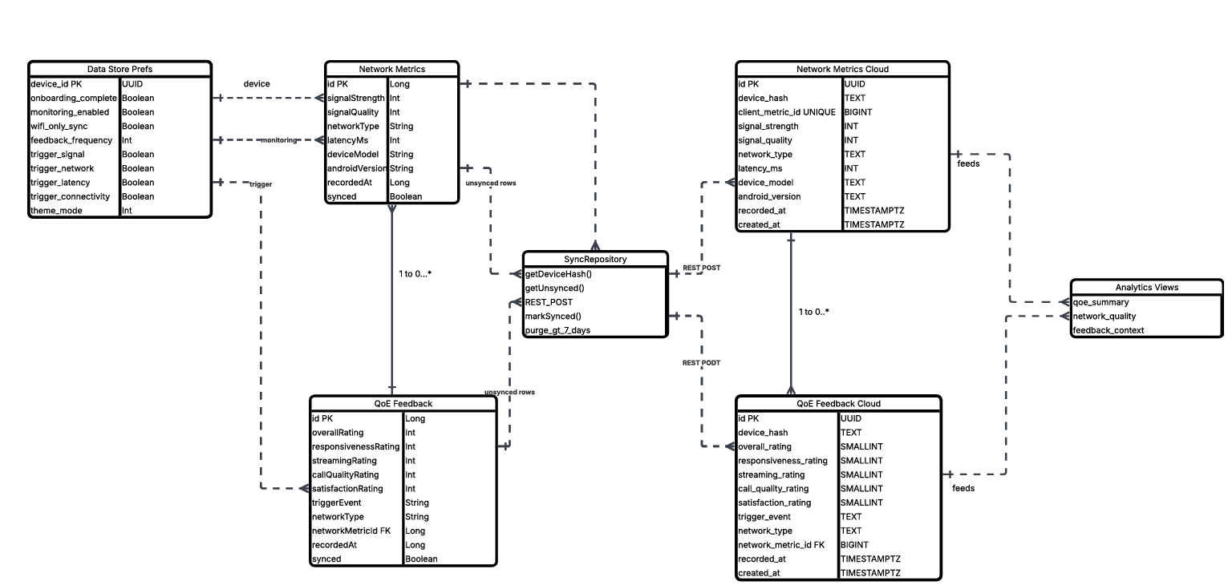
Figure 23:netLink entity-relationship diagram across DataStore, Room, Supabase, and analytics views.

6.4 Database Implementation
Locally, Room (SQLite, database version 3) implements two tables; network_metrics and qoe_feedback, with a foreign key linking feedback to its originating reading. Schema migrations added the linking column and its index across versions 1–3. In the cloud, Supabase mirrors this schema with UUID primary keys, a UNIQUE (device_hash, client_metric_id) constraint to prevent duplicate uploads, CHECK constraints on all rating fields, and Row Level Security policies that restrict the anonymous role to INSERT only.

6.5 Backend Implementation
The backend follows a Repository pattern with Hilt dependency injection across Presentation, Domain, and Data layers. Monitoring components (SignalStrengthCollector, NetworkTypeDetector, LatencyMeasurer, NetworkDegradationDetector) collect readings every 60 seconds and detect events such as a signal drop (≥10dBm fall), a network type change, or a latency spike (+200ms and at least double the previous value). The device UUID is generated once and stored in DataStore; it is never transmitted raw, only as a SHA-256 hash. Synchronisation runs via a WorkManager job every 15 minutes (WiFi-only by default), on manual sync, and after onboarding, uploading unsynced rows to Supabase over Retrofit/OkHttp and marking them synced on success.

6.6 Connecting Database to Backend
Room is provided via Hilt (DatabaseModule.kt) and injected into repositories, which expose Kotlin Flows that ViewModels collect to update the UI reactively; entity mappers convert between Room entities and domain models. The Supabase connection uses a Retrofit client configured with the project's URL and anonymous API key. In practice: tapping "Check now" saves a reading locally with synced = false; tapping "Sync" (or the periodic WorkManager job) uploads unsynced rows and marks them synced; and feedback submissions carry a network_metric_id so that Supabase can later join feedback to its originating reading, scoped to the same device_hash.

6.6.1 Local Database:

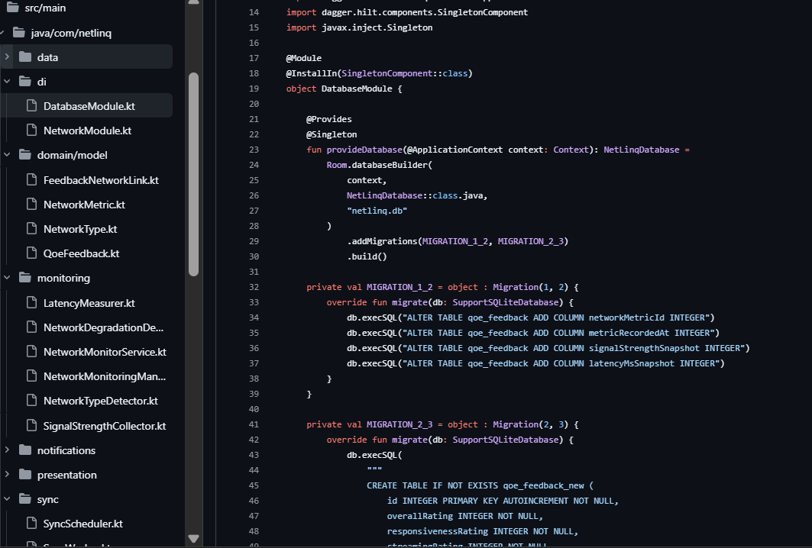
Figure 24:Room Database showing migration

6.6.2 Cloud Database (Supabase with posgresSQL)

This is a sample of subjective user feedback obtained from user’s phones synced to our online posgresSQL database(supabase) with unsynced records which will be added if when the user syncs records, as it will be uploaded from the local database to supabase.
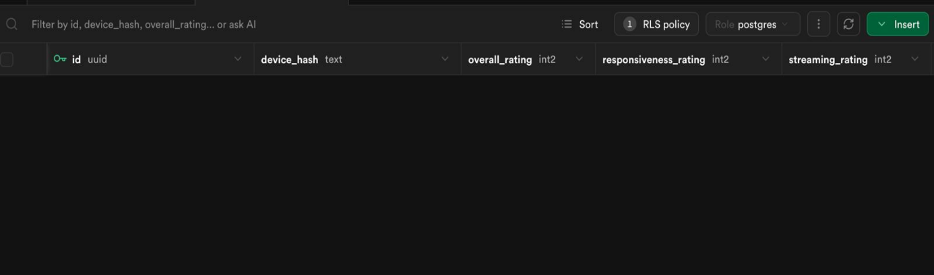
Figure 25:Supabase tables with unsynced records

CHAPTER 7: GOALS ACHIEVED

7.1 Summary of Achievements

The final netLink application successfully realizes the majority of features derived from the initial requirement gathering phase, as follows:
- Passive Background Network Monitoring: The system delivers automatic collection of signal strength, network type, and latency through a Foreground Service, directly addressing the 89.4% of surveyed users who could not explain why their network degraded but confirmed it did.
- Low-Friction, Privacy-Respecting Feedback: This is met through a dual feedback path: a single-tap Quick Rating Sheet for event-triggered prompts (signal drop, network change, latency spike, connection loss) and a detailed 5-category form for voluntary entries, both completable well under the 30-second usability target.
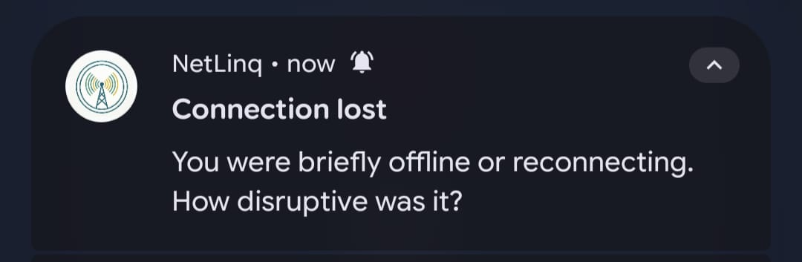
Figure 26:event triered notification prompts
- Anonymity and Privacy: Concerns raised by 65.9% of respondents are addressed structurally rather than cosmetically. The 5-step onboarding flow replaces traditional authentication entirely, and only a SHA-256 hashed device ID is ever transmitted, with raw UUIDs and personal identifiers never leaving the device.
- Offline-First Operation: Critical given the very network instability the app is studying, this is fully implemented via Room local storage with a synced flag, WorkManager-driven periodic sync, and automatic 7-day purge of confirmed-synced records.
- User-Facing Dashboard and History: Satisfied through the Network Dashboard and QoE History screens, giving subscribers visibility into their own data (latency trends, signal quality, past ratings) rather than only contributing to a one-way system.
- Operator-Facing Analytics: Delivered through a dedicated operator dashboard, built on top of the Supabase aggregation views (operator_qoe_summary, operator_network_quality, operator_feedback_with_context), allowing operators to download aggregated, anonymized QoE data and visualize quality-of-experience trends across network type and time. For future work, this dashboard is intended to evolve from trend visualization into automated experience reports, surfacing actionable insights that operators can act on directly to improve network quality, closing the loop between subscriber-reported experience and operator-side decision-making.

CHAPTER 8: SWOT ANALYSIS AND FUTURE ENHANCEMENTS

8.1 SWOT Analysis

8.1.1Strengths
- Subscriber-side data collection
netLink collects QoE data directly from the subscriber's device. The only point in the entire mobile network chain where subjective experience and objective device readings can be captured simultaneously. No operator infrastructure modification is required. The system works independently of any cooperation from MTN or Orange Cameroon.
- Offline-First architecture
The system is designed around network unreliability rather than despite it. Room Database guarantees zero data loss regardless of connectivity state. The app functions fully offline and synchronizes opportunistically, making it robust in exactly the environments it is designed to study.
- Privacy by design
The SHA-256 device hash anonymization is irreversible. No personal data exists in the cloud. Row Level Security restricts the mobile application to INSERT only. Operators access only aggregated views. This architecture eliminates the most common adoption barrier identified in the survey; subscriber privacy concern at the architectural level rather than through policy promises.
- Event-based prompts over fixed intervals
By triggering feedback prompts only when meaningful network events occur like; signal drops, call ends, latency spikes, the system collects contextually relevant ratings at the moment of experience rather than after the fact. This improves both data quality and user experience, directly addressing the notification fatigue finding from the Task 2 survey.
- Cost-effective infrastructure
The entire backend runs on Supabase's managed PostgreSQL platform, requiring zero server administration from the development team. Pilot-scale deployment runs at zero infrastructure cost. The tooling stack is entirely open source.
- Three-actor RBAC architecture
Database policy levels ensures that subscribers, operators and administrators each operate in a clearly defined, secure and visually distinct environment within the same system.

8.1.2 Weaknesses
- Android-only platform
The exclusion of iOS, while technically justified, limits the system's addressable subscriber base. Although Android dominates the Cameroonian market, MTN and Orange Cameroon do have a non-trivial iOS subscriber segment, particularly among higher-income users whose network experience data may be analytically valuable to operators.
No operator dashboard in current scope
The Supabase SQL views that power operator analytics are complete, but the authenticated web dashboard through which operators would consume them is designated as a Phase 2 deliverable. In the current implementation operators have no polished interface for their analytics — only raw Supabase table access.
- Dependent on user willingness to rate
Despite event-based triggering, the system ultimately depends on subscribers choosing to respond to feedback prompts. Users can dismiss every prompt without rating. A low response rate would produce sparse feedback data that limits the statistical reliability of operator analytics aggregations.
- Battery and OEM firmware variability
Devices apply aggressive and non-standard battery optimization policies that can terminate background services in ways that stock Android does not. While the hybrid event-based architecture mitigates this, there is no guarantee of consistent monitoring behavior across all device models and firmware versions in the Cameroonian market.
- No real-time operator alerting
Operators currently access analytics through periodic aggregation. There is no mechanism for real-time alerting for example, notifying an MTN engineer immediately when the average QoE score in a particular area drops below a threshold. Operators discover trends retrospectively rather than being alerted to emerging problems.
- Single-region pilot scope
The current system has no geographic tagging of readings beyond the implicit location inference available from network cell data. Without explicit geographic segmentation, operators cannot pinpoint degradation to specific areas, towers or coverage zones.

8.1.3 Opportunities
- Operator partnership and formal data licensing
If MTN Cameroon or Orange Cameroon formally adopt netLink data as a complement to their existing QoS monitoring infrastructure, the system could be deployed at scale with operator-backed distribution, pre-installation on operator-sold devices or inclusion in operator app stores dramatically expanding the subscriber base and data volume.
- ART regulatory leverage
The Telecommunications Regulatory Authority of Cameroon (ART) could adopt netLink data as an independent, subscriber-side validation layer for operator-reported QoS compliance. This would give the system regulatory significance beyond its current academic and commercial scope.
- Machine learning on aggregated data
As the cloud dataset grows, the aggregated metric and feedback records become a training corpus for predictive models. A machine learning layer on top of the Supabase data could predict QoE degradation events before they are reported, identify coverage holes from patterns in historical readings, and recommend network investment priorities to operators based on where and when subscriber experience is worst.
- Integration with operator network management systems
With formal operator partnership, netLink data could be integrated directly into existing Network Management System (NMS) platforms used by MTN and Orange, creating a unified view that combines infrastructure QoS metrics with subscriber-side QoE data in a single operator dashboard.
- Academic and research value
The anonymous dataset produced by netLink; timestamped, network-typed, device-specific QoE readings from real subscribers in Cameroon, would be of significant value to telecommunications research institutions studying mobile network quality in developing markets. The University of Buea itself could use the data for research publications.

8.1.4 Threats
- User adoption and retention
The most significant operational threat is that subscribers install the app but do not maintain it. Android users on affordable devices are sensitive to battery consumption and storage usage. Any perception that netLink drains the battery or consumes storage could lead to uninstallation at scale, which would undermine the data volume needed to make operator analytics statistically meaningful.
- Android platform policy changes
Google regularly tightens background processing restrictions across Android versions. Future Android releases could further restrict Foreground Service behavior, WorkManager scheduling frequency or TelephonyManager API access in ways that require significant implementation changes to maintain monitoring functionality. The Doze mode evolution from Android 6 through Android 14 illustrates this ongoing risk.
- OEM firmware updates
Phone companies periodically release firmware updates that change battery optimization behavior. An OEM update could effectively disable the monitoring service on a large proportion of the installed base without any change to the netLink codebase, requiring reactive fixes and user guidance updates.
- Data privacy regulation evolution
Cameroon's Law No. 2010/012 on Cybersecurity and Cybercriminality governs data collection. As African data protection regulation evolves, particularly with the influence of GDPR-inspired frameworks spreading across the continent, additional requirements around consent, data minimization and user rights may impose compliance obligations that require architectural changes.
- Operator resistance
Network operators may perceive netLink as a reputational risk, a tool that generates and publicizes evidence of poor network quality. Without a formal partnership framework, operators could resist adoption or use their market position to discourage subscriber participation. This is particularly relevant if the system is positioned as adversarial rather than collaborative.

Future Implementations
- Operator-Specific Data Routing:
The most immediately impactful future enhancement is separating subscriber data by network operator so that each operator receives only the data generated by their own subscribers. In the current architecture, all subscriber data flows into a unified Supabase database where operator views aggregate across all records. A subscriber on MTN and a subscriber on Orange both contribute to the same pool.
The implementation would work as follows. During onboarding, the subscriber selects their network operator; MTN Cameroon, Orange Cameroon, Camtel or Other. This selection is stored in DataStore as a preference field. When records are uploaded to Supabase, the operator identifier is included in the payload as a non-identifying categorical field, not the subscriber's account with that operator, simply the network brand. Supabase Row Level Security policies are then extended so that each operator role can only view data filtered to their own operator identifier.
This change transforms netLink from a single-pool analytics system into a proper multi-tenant operator analytics platform, where each operator has a private, walled view of their own subscriber QoE data while the underlying infrastructure remains shared. It is the single enhancement most likely to make formal operator partnerships viable, because it addresses the commercially sensitive concern that competitors could access each other's subscriber data.

8.3 Additional Future Implementations
1. Real-time operator alerting
A Supabase Edge Function triggered when average QoE scores in a time window drop below a configurable threshold, sending an email or webhook notification to registered operator contacts. This converts the current retrospective analytics model into a proactive alerting system.
- iOS limited-feature version
While full monitoring is impossible on iOS due to Apple's API restrictions, a limited iOS companion app could collect subjective user ratings manually and basic connectivity state without TelephonyManager data. This would extend the subscriber reach to the iOS segment while clearly communicating the reduced monitoring scope.
- Machine learning QoE prediction
As the dataset matures, a predictive model trained on historical metric and feedback correlations could forecast QoE degradation events before subscribers experience them, enabling proactive operator intervention rather than reactive response.
- Offline operator dashboard
A dedicated Android tablet application for operator field engineers, which can download aggregated analytics for offline viewing during site visits in areas without stable internet, extending operator access beyond the web dashboard to field conditions.

APPENDIX (Table of Figures)
Figure 1:Questionnaire1 12
Figure 2:Questionnaire2 12
Figure 3:Questionnaire3(frequency of problem) 12
Figure 4:Questionnaire4(most used network service provider) 13
Figure 5:context diagram 24
Figure 6:Dataflow diagram 25
Figure 7:Use case diagram 26
Figure 8:sequence diaram 27
Figure 9:class diagram 28
Figure 10:Deployment diaram 29
Figure 11:Netlinq logo for dark mode 30
Figure 12:Onboarding screens 32
Figure 13:Network Dashboard showing live signal, latency, and connection type. 32
Figure 14:Detailed Feedback form with five star-rating categories and text feedback 32
Figure 15:QoE History screen with latency trend and quick-feedback prompt. 33
Figure 16:Settings screen controlling monitoring, triggers, and sync. 33
Figure 17;MVVM Architecture showin presentation layer for mobile subscriber frontend 35
Figure 18:Operator dashboard 36
Figure 19:netLink entity-relationship diagram across DataStore, Room, Supabase, and analytics views. 38
Figure 20:Room Database showing migration 39
Figure 21:Supabase tables with unsynced records 40
Figure 22:event triered notification prompts 41

REFERENCES
Google Forms survey data collected by Group 23 (123 responses), Cameroon, 2026.
Interview with MTN Technology Department staff, conducted by Group 23, 2026.
Speedtest by Ookla, OpenSignal, and MyMTN applications, reviewed for competitive/reverse-engineering analysis, 2026.
Group 23, "Report on the Design and Frontend Implementation of a QoE Application (netLink)", CEF440, University of Buea, June 2026.
Group 23, "NetLinq: Database Design and Implementation", CEF440, University of Buea, 2026.

